**TWIN CREEKS – Just a Day Out**

**Sunday 20th September, 2020**

Another very successful day although it looked grim only 20 minutes before the first group were to go with consistent rain and heavy overcast skies.

Five minutes to 10:00am and the rain stopped, skies cleared, blue patches appeared and then the sun came out. No more rain and just a light occasional wind escorted us around the course and we enjoyed good weather conditions with only a few wet patches.

Col Dunn failed to meet his allocated tee time so 19 of us set out including four new Hackers in Malee Vanderwiel, John Wright, Steve Herne and Tony Donnellan. Because of Col’s absence, under ‘Hackers’ rules the Green Team received an adjustment of the average of the remaining team members’ scores to compensate for being one member short.

The greens having been recently cored were a great disappointment and there were many 3 and even a report or two of 4 putts. The bunkers were very poor and were GUR where signposted and preferred lies in all others. The fairways were reasonable considering we are coming out of winter but all in all I think it is the worst condition I have experienced at one of my favourite courses and I have played there probably a dozen times.

**Full Results of the Day**

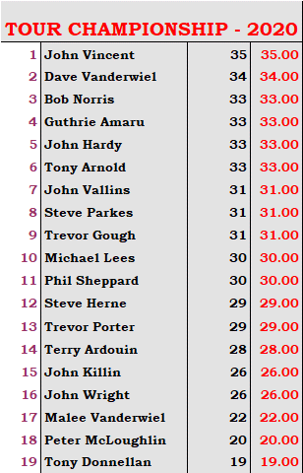 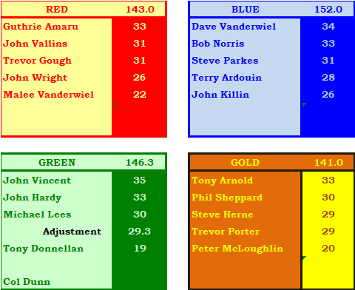

For the first time The Hackers played a 2BBB where every player was paired with everyone in the whole field and, in a field of 20, this results in 190 combinations.

There were 3 combinations with the best score of 45 points and the winners on a countback were the two left-handed Jayvee’s from Runners/Up John Vincent and Bob Norris. In 3rd place was Bob Norris and Dave Vanderwiel.

Countback as follows – Last 9 holes played then Last 6 holes played then Last 3 holes played;

John Vincent and John Vallins :: 23 – 16 - 7

John Vincent and Bob Norris :: 22 – 15 - 8

Bob Norris and Dave Vanderwiel :: 21 – 14 – 8

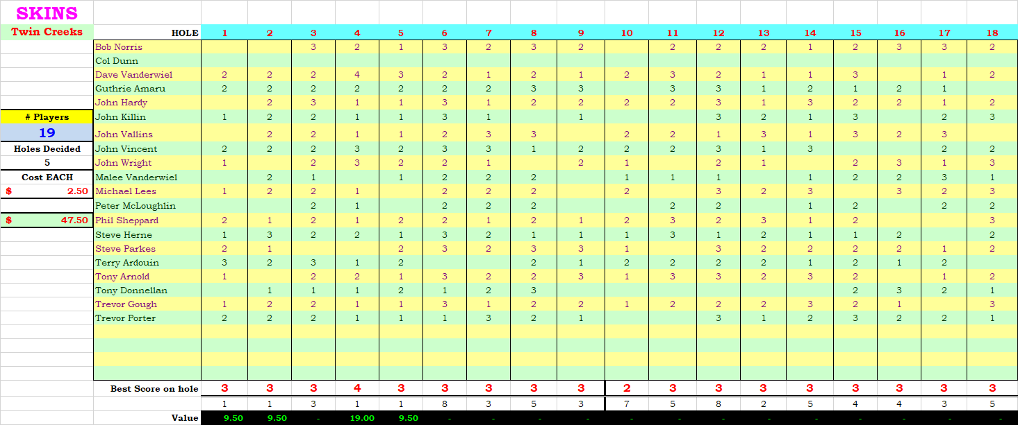

Skins cost $2.50 each which is the lowest cost per player in Hackers history.

